HOW TO WAY AUTHORIZE
1/ Via Text
2/ Via upload ID Me
3/ Upload document – ID
Client need to do 2 step:
Step 1: Click into the link on phone
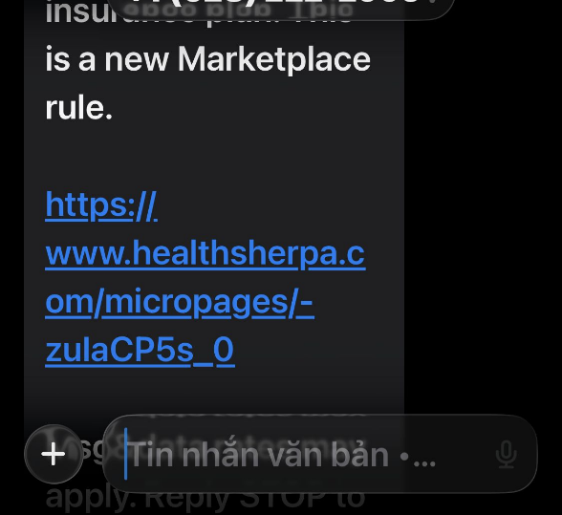
Step 2: Choose Anh Pham show on screen – DONE
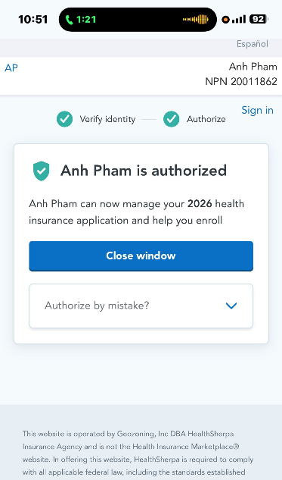

If unable verify by that ways, client will see 2 another option ( verify with ID Me & verify with docs)
Choose option: Verify with Document – upload ID picture – Scan the face – Done

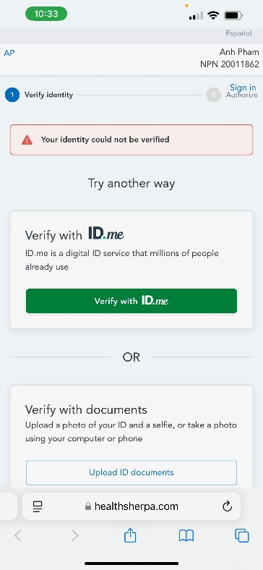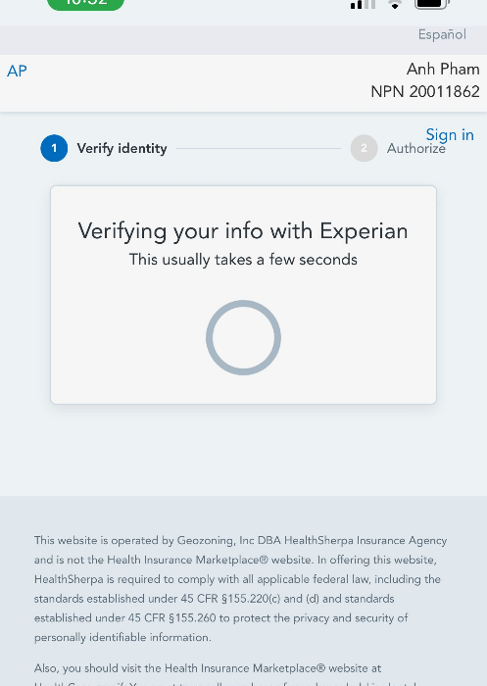

HSP SHOW:


